

Friday 9th October 2026

Parent Newsletter
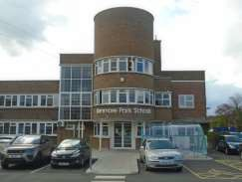

A word from the Head Teacher:
Dear Parents and Carers,
We have now been back at school for 5 weeks and in that time we have achieved a lot. I am delighted with how both the nursery and Reception children have settled into their new classes. The children who are new to our school have also done exceptionally well. There is always a lot for them to get used to and already they look like they have been here for longer than just 5 weeks.

Year 1 teachers have delivered their excellent story telling workshops for parents and I hope that you were able to come along and enjoy one of these. These sessions are so important as they give you a glimpse of what we are doing in the classroom with your children and the teachers here are a very skilled team of professionals who are only too glad to showcase what they are doing on a daily basis in their classrooms. Thank you to all those parents who managed to find time to come to these.

Huge thank you to Ms Dobrica who organized the autumn coffee morning for parents earlier this week and it was lovely to see so many of you at this. I hope you were made to feel welcome and enjoyed the food and treats that Ms Dobrica organized for you.

Please remember the Year 1 assembly for parents is next week on Monday 12th October at 1.05pm. All year 1 parents are welcome to attend. Also do not forget about the Reception phonics seminar lessons we are putting on for parents and please come to these as it is a golden opportunity for you to see how we are teaching children to read in the Reception classes. In addition to these we are holding the target setting parents evenings next week so please make sure you have booked via weduc for these important meetings on Tuesday and Thursday evenings with your child’s class teacher.

This week we had our most recent visit from the specialist teacher at the English hub who are working with us to support our phonics curriculum and she was delighted with what she saw. The teaching was excellent and in her words we could not have made a better start to the academic year in terms of our phonics curriculum. She focused heavily on Reception and Year 1 and was highly complementary about all the lessons she observed. So a huge well done to all the children who she mentioned were superbly behaved in all lessons observed and a massive thank you to the teaching team at KPINS who are amazing.

We are now just two weeks away from the autumn half term holiday but there is so much still to do before we get there, so we keep working hard and making sure that the children who come to KPINS get the very best educational opportunities. However, in order for us to do this you must make sure your child is in school and on time every day. I have already had too many requests from parents for time off for trips and other non-essential absences and my answer to this will always be no. If your child is here we can teach them and they will get an excellent education. Every day they spend away from school is golden learning time missed.

Please enjoy your weekend and I look forward to seeing you and your children again next week.

My very best wishes,

Steve Davies (Head Teacher)

Dates for your diary for the rest of this year:
This term is a long one and as ever, there is so much to do. I have listed some of the key dates below so that you can be fully prepared for what is coming up:

Please note below the school term dates and holidays.
These are shared in the BI-weekly newsletter and can be found on the school website. Therefore, there is no excuse for any parent to claim they are not aware when making requests for leave which needs to be avoided during term time.

The 2026/2027 term dates can be found on the school website. So make sure you check them out before making any travel arrangements.

Autumn Term 2026
First day of school Thursday 3rd September
Half term- Monday 26th to Friday 30th October
Back to school Monday 2nd November
Last day of term Friday 18th December (finish at 2 p.m. Reception & 2.15 p.m. KS 1)*
Back to school Monday 4th January 2027
*NB: Reception finish at 2 p.m. and years 1 & 2 (KS 1) will finish at 2.15 p.m. on the last day of each term. This does not apply to half term holidays.
There is no afternoon nursery session on the last day of each term due to the early finish time. Please note there is NO school on Bank Holiday.

Key School Events for parents-not to be missed:

Date: | Event | Times:
Monday 12th October  Monday 12th October | English workshop on phonics Robin Class parents.  Year 1 assembly to parents | 9am in school hall  1.05pm in school hall
Tuesday 13th October  Tuesday 13th October | English workshop on phonics Robin Class parents.  KS 1 parents meet the teacher for target setting | 9am in school hall  3.45-5.30pm
Thursday 15th October  Thursday 15th October | English workshop on phonics Robin Class parents.  KS 1 parents meet the teacher for target setting | 9am in school hall  4pm-7pm
Monday 19th October | Year 2 assembly for parents | 1.05pm in school hall
Tuesday 20th October | Math’s works shop for KS 1 parents | 9am in school hall
Thursday 22nd October | English workshop for KS 1 parents | 9am in school hall
Friday 23rd October  LAST day of half term | KS 1 achievement assembly to invited parents | 1.05pm

Attendance reminder ….
This half term the school LA Attendance Liaison Officer will be visiting the school to review attendance data and scrutinising the attendance of those children whose attendance has:
- Not improved since notice given earlier in the year based on the autumn term review.
- Fallen or continues to be below 90% as these children will be deemed persistent absentees and track to see if this is a historical pattern.
Letters will be sent out to parents expecting improvements to be made and attendance contracts drawn up in some cases.
Where improvements are not made – referrals may be made to the pre-court panel particularly if attendance issues are historical.
We would like to ensure that none of our parents are required to attend court or threatened with prosecution due to issues relating to their child’s attendance so please work with us to ensure good attendance and learning outcomes which are closely related!

We appreciate that we have recently experienced an outbreak of Chicken Pox across the school. However, like any other absence it is important to provide medical evidence and bring your child to the school office prior to their return to check that their spots have dried up, they are no longer contagious and fit to return to school.

We are also mindful that there is another outbreak of Measles hitting London boroughs and impacting schools. This is a preventable virus if children are vaccinated against it. We encourage parent/carers to take measure to ensure that their children are protected from unnecessarily ailments which have a negative impact on health, attendance and learning.
I would like to remind parents of the exceptional leave criteria. Exceptional leave is absence that is necessary in an emergency and usually immediately on the day or as close to the day the leave request is made. All evidence provided must substantiate the request. Exceptional leave does not include time off to attending family and friend events abroad (which is a choice) or medical treatments that could be accessed here in the UK. Where parents have made decisions to travel and take their child out of school we ask parents to make an appointment to discuss their plans prior to making any bookings so that parents are made aware of the implications of their decisions.

Where leave is taken during the term time it is unlikely to be approved and could result in an educational penalty notice – FINE of a minimum of £80 per child per parent.
We have noticed patterns of attendance falling particularly prior to or immediately after a school holiday – please ensure that you make arrangements to travel during school holiday time and not during term time. Outward bound and inward bound bookings should demonstrate intention to travel and return before the school resumes after travel during a school holiday.
Due to the increase in the number of parents travelling during the school holidays and then claiming their child/ren or they then become too sick to travel back in time for the start of the school, the school will not be approving this leave (it will be recorded as unauthorised). Overseas medical evidence will not be accepted.
We are not obliged to accept medical evidence from abroad. Unfortunately, it has come to light that too many parents are using this as an excuse to extend their time aboard and a consistent approach will be applied.

The law has changed; you do not need to have 5 consecutive days of absence to qualify for a penalty notice an aggregate of any unauthorised absence during a set period provided they total 5 or more days can result in fines.
Also please note any absences during the last week prior to a school holiday will need to be evidenced in line with the LA absence procedures. You will be required to have your child’s sickness checked by the school welfare, so the child will need to be brought into school and the welfare Miss Nubuor will check to see if the child is fit to be in school or not. Alternatively, medical evidence will need to be requested from a GP in the form of a print out of the in person consultation (not over the phone) and proof of any medication prescribed. We have also been informed by the Court Attendance Officer to also check the child’s passport on their return to school as evidence that they have not travelled and used sickness absence as an excuse.
Please be reminded that a fine to parents must be considered if a child misses 5 days of school for unauthorised absence. The cost for the fine is £80 (per parent) if paid within 21 days and £160 if paid in 28 days. If a second fine is issued within a 36-month period, it will start at £160 per parent.

Note that every time your child is absent from school they are missing an average of 5 lessons per day. Over a school week that amounts to over 25 lessons missed.

TERM TIME LEAVE not permitted! Exceptional circumstances mean exceptional!
Religious leave in line with the Harrow SACRE Calendar only.
Honesty is the best policy!

Please note the guidance on sickness absence that can be authorised below with evidence to support it.
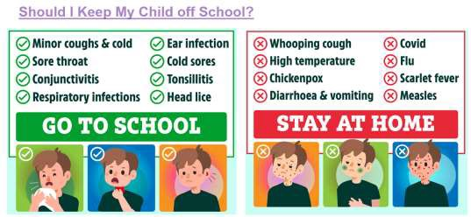


A REMINDER OF OUR COMPULSORY SCHOOL UNIFORM & PE UNIFORM
Please be reminded that the school takes a hard line regarding compliance with the school uniform. It is parents’ responsibility to ensure that their child is wearing the school uniform as stipulated in the school prospectus and website. On Wednesday’s we require all children in Year 1 and 2 to wear the schools PE uniform which comprises of Grey joggers (Option of black shorts in the summer) a grey top and black trainers/plimsolls and not their own sportswear. This
uniform can also be worn for PE lessons, in line with their class timetables, on days other than Wednesday. All Uniform orders can be made via the Weduc App at the school shop.

It has been noted since the start of the school term that a number of children are not wearing the
appropriate clothing and black shoes. Please respect the school’s policy and practice by ensuring your child comes to school in the correct uniform. We thank you in advance for your support and compliance.
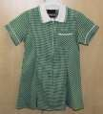
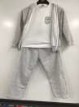
During the summer term pupils permitted to wear the following:
Girls may wear Black or Grey Trousers too. White socks or grey tights
Boys’ black or grey socks.
Summer dress from April – July only

Useful website:
Please find below link to the Bell Foundation website which provides translated guidance for parents on the education system in the UK and the expectations.
https://www.bell-foundation.org.uk/resources/guidance/parental-involvement/guidance-for-parents-english-education-system/

FREE SCHOOL MEAL ELIGIBILITY CHECK worth checking as the government continue to give food vouchers during the holidays!
It is important that parents check their eligibility criteria as a number of parents found themselves to be eligible during lockdown. They were then issued with free school meal vouchers which they could use to purchase food at a supermarket of their choice. It is important that you check as it may be helpful in the event of a second spike!
Parents can check to see if they meet the eligibility criteria by following the instructions below: Step 1: Login to the following website: https://pps.lgfl.org.uk (Free School Meal Eligibility Checker)
Step 2: Click – Check eligibility
Step 3: Click – create an account (Unless you already have an account in which case you go to return to your account and enter your password)
Step 4: Create an account
Step 5: On the drop down menu:
Local authority – select - Harrow
School – select – Kenmore Park Infant & Nursery School.HA3 9JA
Step 6: Read and accept the privacy notice by ticking the box at the bottom of the page. Step 7: Enter your details:
First name Last name

Your date of birth
Your National Insurance number Email address
Mobile number Postcode
Get address: click on your address; house number etc SUBMIT
Once you have submitted the form you will receive a response in a couple of days confirming your status. If you are eligible, please forward the email to the school on the following email address: office@kpins.harrow.sch.uk

Kenmore Park Infant and Nursery School super star
writers and readers:

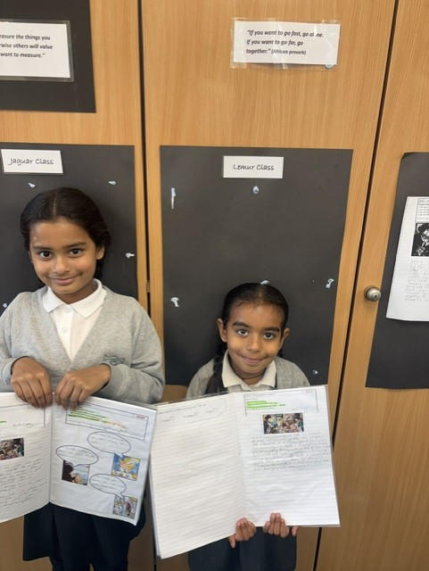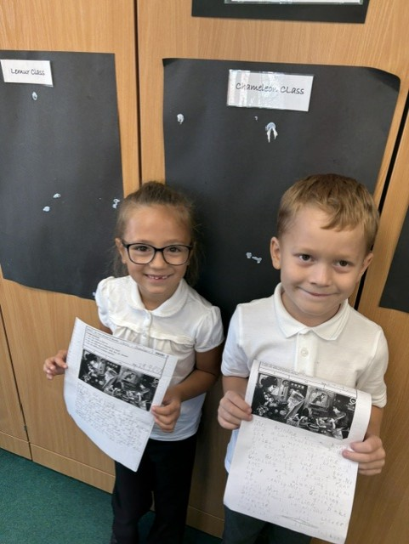
Writers of the week from Lemur Class Writers of the week from Chameleon CLass
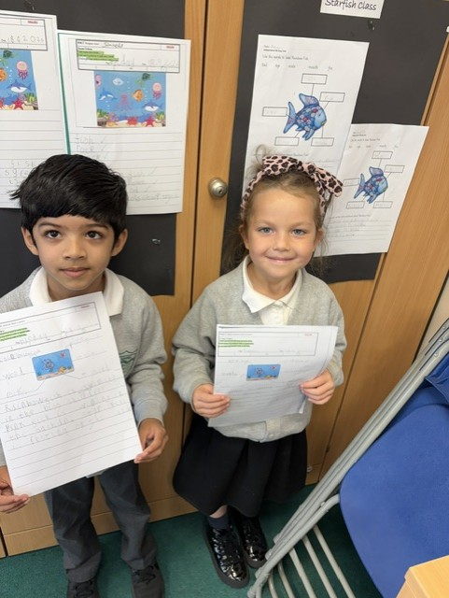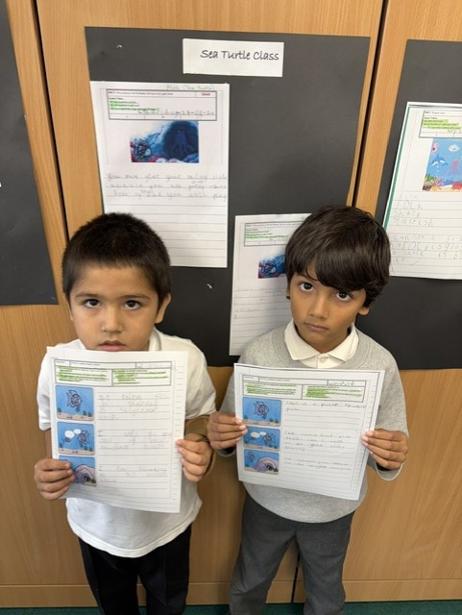
Writers of the week from Octopus Class Writers of the week from Sea Turtle Class
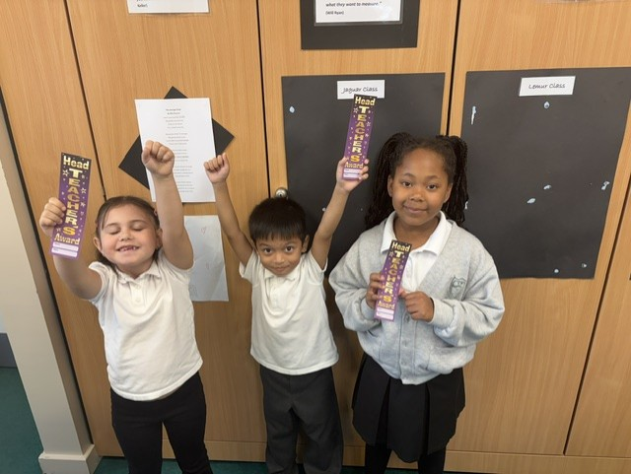
Writers of the week from Jaguar Class
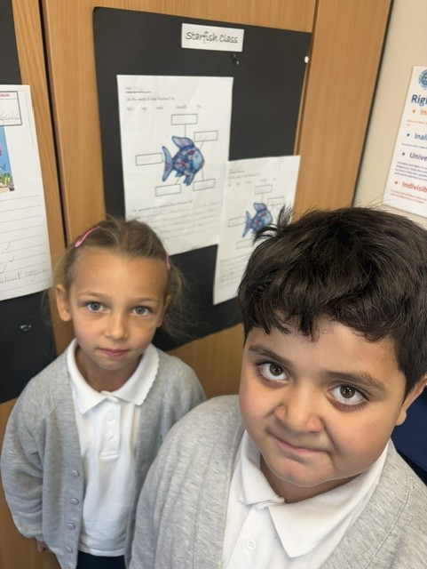
Writers of the week from Octopus Class
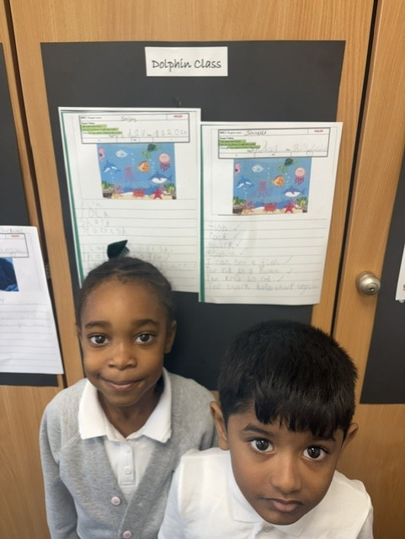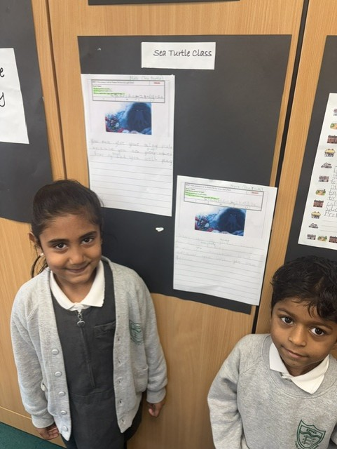
More writers from Dolphin Class More writers from Sea Turtle Class

Readers of the week:
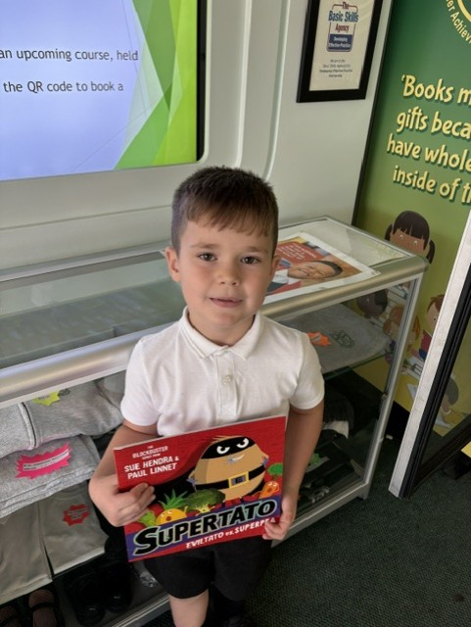
An expert reader from Dolphin Class

IMPORTANT REMINDER:
If you do not wish for your child’s photograph to be shared in the monthly newsletter please send an email to the school office: office@kpins.harrow.sch.uk subject: reading vending machine pictures, Stating: I wish for my child to opt out of having their image shared in the monthly newsletter if they receive a free reading book from the reading vending machine.

If we do not hear from you, we will assume you are happy to allow your child’s picture to be shared and uploaded onto the school website too as part of the monthly newsletter!

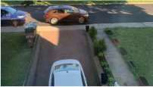
Reminder about Parking
We continue to receive complaints from local residents - Residents report parents persistently blocking their drive ways and confirm that at no time have they given permission to any parents to park in front of their drive ways. A number of the residents have shared they have life threatening medical conditions which require them to have immediate, emergency
access to their drive ways – so please respect their wishes and if no spaces near the school are available – park and walk, the exercise is good for everyone.

A Parent Governor vacancy open.
The governing bodies of the two schools are looking to recruit a Parent Governor from either school to join the newly formed federated Governing Body from September. Therefore, if you are interested in becoming a parent governor please visit the school office for a nomination form or email office@kpins.harrow.sch.uk with subject – Parent Governor nomination form and we will email you one out to you.
Please enjoy a safe and restful weekend with your children and I look forward to seeing you and them, next week for another action packed, fun-filled week at KPINS.
Very best wishes,
MR S Davies


